UofL Research & Innovation Website Renovation

Version <1.0>

Revision History

|  |  |  |  |
| --- | --- | --- | --- |
| **Date** | **Version** | **Description** | **Author** |
| <27/Jan/20> | <1.0> | <First Iteration> | <Ruomei Wang> |
|  |  |  |  |
|  |  |  |  |
|  |  |  |  |

Table of Contents

1. Introduction 4

1.1 References 4

2. Positioning 4

2.1 Problem Statement 4

2.2 Product Position Statement 4

3. Stakeholder and User Descriptions 4

3.1 Stakeholder Summary 5

3.2 User Summary 5

3.3 User Environment 5

3.4 Summary of Key Stakeholder or User Needs 6

3.5 Alternatives and Competition 6

4. Product Overview 7

4.1 Product Perspective 7

4.2 Assumptions and Dependencies 7

5. Product Features 8

6. Other Product Requirements 8-9

# Introduction

This vision document is to collect, analyze and define high-needs and features of the University of Louisville Research and Innovation website renovation. The document focuses on the capabilities needed by the stakeholders and the target users, and the improvements provided by the renovation.

## References

1. Ambler, Scott W, and Matthew Holitza. “*Agile For Dummies®, IBM Limited Edition*.” Print.

2012.

2. Dennis, Alan, et al. *Systems Analysis and Design with UML, 4th Edition*. John Wiley & Sons,

2012.

3. *Front Page - Research and Innovation*, University of Louisville, louisville.edu/research.

# Positioning

## Problem Statement

|  |  |
| --- | --- |
| The problem of | The UofL Research and Innovation webpage is difficult to navigate |
| affects | UofL students and faculty, researchers, industry |
| the impact of which is | Results in less researchers, students, and organizations involved in this program, and in the end affects the revenue of UofL research office |
| a successful solution would be | Renovate the website menu and layout |

## Product Position Statement

|  |  |
| --- | --- |
| For | UofL Research Center |
| Who | Needs more revenue to fund research |
| The (product name) | A website |
| That | Attracts more industry and conducts further research |
| Unlike | Other research instructions and facilities |
| Our product | Clear layout and navigation for target customers |

# 

# Stakeholder and User Descriptions

## Stakeholder Summary

|  |  |  |
| --- | --- | --- |
| **Name** | **Description** | **Responsibilities** |
| Louisville community | Residents of Louisville who want success for our University | Residents of Louisville can promote our University’s research and innovation |
| University of Louisville employees | UofL employees who wants to see our University thrive on research | UofL employees can work more efficiently and effectively to help approve fundings and monitor research progress |
| Louisville Metro Government | Louisville government that helps UofL become a better University | Louisville government can maintain a safer environment for UofL students and researchers |

## User Summary

|  |  |  |
| --- | --- | --- |
| **Name** | **Description** | **Responsibilities** |
| Students | UofL students who wants to participate in research | Engage in learning and participate in research actively |
| Researchers | UofL researchers who wants to innovate and discover new things | Lead students to rewarding and meaningful research, and provide the industry better solutions |
| Industry | Industry that needs technology solutions and advanced knowledge | Reach out to our University and help conduct the solutions given by the researchers |

## User Environment

1. Students: it is not easy to see the research area, latest news and admission requirements. Which will affect number of students who apply and join the program.
2. Researchers: it is not easy to find all the research activities like latest meeting, new researches, resources this cause delay in producing research and number of researches that they are doing.
3. Industry: not having enough university industry collaborations affect

* Amount of funding: The Industry partnerships give students and faculty additional funding.
* More resources: By striking up corporate partnerships, universities have more resources to undertake research, and they’re able to diversify their research areas.
* Get more in the market: Universities know that some problems can’t be solved in isolation in a lab, and industry feedback is key to taking an invention or product from conception to market.
* Expose students to the industry culture: Companies are hungry for ideas, and the actual technologies and intellectual properties to commercialize those ideas. And, companies are hungry for talent. This is a very good opportunity to expose students to the industry culture. When students graduate, they are better prepared to start working at these companies.
* The benefits for companies continue to stack up, including access to a network of faculty, key opinion leaders, and lead scientists, and the ability to team up with other companies interested in the same research.

## Summary of Key Stakeholder or User Needs

|  |  |  |  |  |  |
| --- | --- | --- | --- | --- | --- |
| **Need** | **Priority** | **Concerns** | **Current Solution** | **Proposed Solutions** | |
| Getting more fundings for UofL research | High | UofL research website is not intuitive enough to help users navigate information | Renovate the menu and layout | | Overhaul the website to make it more intuitive and create better design |

## Alternatives and Competition

|  |  |  |
| --- | --- | --- |
| **Institution Name** | **Strengths** | **Weaknesses** |
| University of Kentucky | * Clear display of achievement and breakthroughs | * Lack of an intuitive navigation menu * Hard to find funding information |
| Indiana University Bloomington | * Great website design * Good narratives about research achievements | * Lack of an intuitive navigation menu * Some buttons could be confusing * Hard to find funding information |
| Ohio State University | * Dedicated section for research news | * RSS is a broken link * Website is too simple, not substantial or concrete enough * Hard to find funding information |
| Yale University | * Great website design * Clear separation for different users between researchers and industry | * No dedicated entrance button for students * Hard to find funding information |

# Product Overview

## Product Perspective

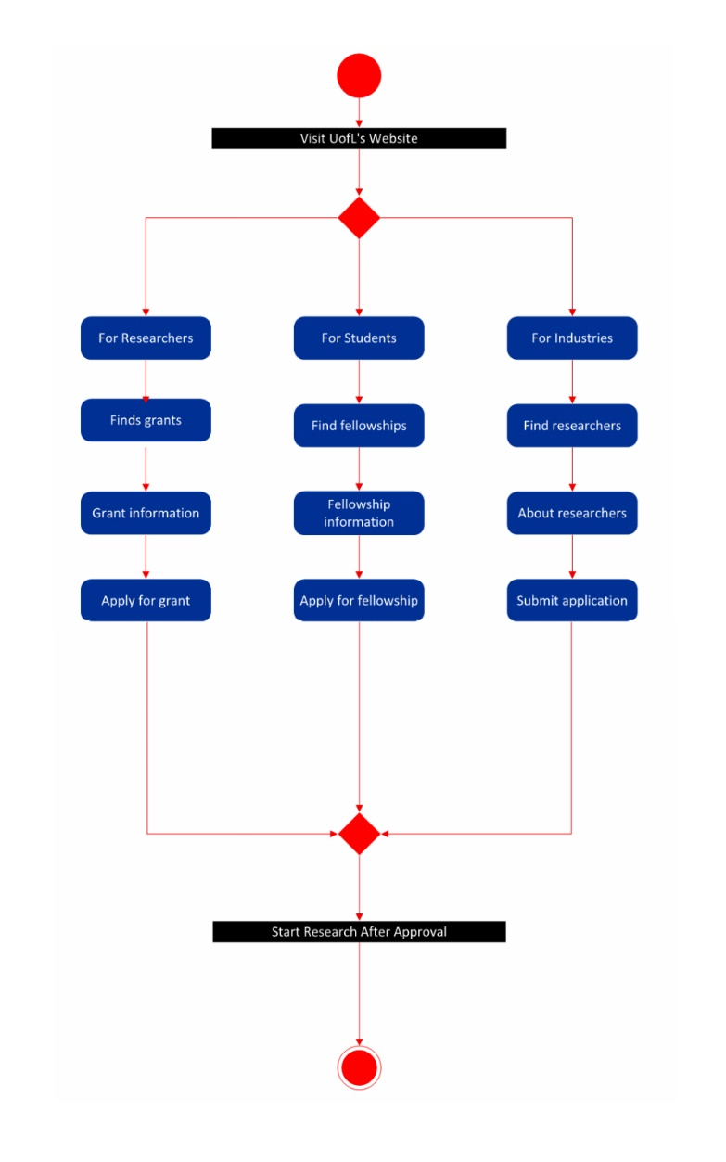

## Assumptions and Dependencies

1. The default language will be English. It is assumed that users who cannot speak and write in English will be using translated webpages.
2. When using the search feature, it is assumed that users are literate and can type.
3. It is assumed that users will have network connectivity so the website is accessible via web browser.

# Product Features

1. Intuitive Navigation Menu
2. Good Graphic Designs
3. Separation of Resources for Different User Groups
4. Recent News and Latest Researcher Meetings and Conferences News
5. New Research Program Announcement
6. Newsletter Subscription
7. Admission Requirements
8. Funding Application
9. Dedicated section of Funding Information

# Other Product Requirements

1. Academic:

* Provide more resources to students: By striking up corporate partnerships, universities have more resources to undertake research, and they’re able to diversify their research areas.
* Get more in the market for the students: Universities know that some problems can’t be solved in isolation in a lab, and industry feedback is key to taking an invention or product from conception to market.
* Expose students to the industry culture: Companies are hungry for ideas, and the actual technologies and intellectual properties to commercialize those ideas. And, companies are hungry for talent. This is a very good opportunity to expose students to the industry culture. When students graduate, they are better prepared to start working at these companies.
* The benefits for companies continue to stack up, including access to a network of faculty, key opinion leaders, and lead scientists, and the ability to team up with other companies interested in the same research.

1. Organizational:

To measure how well the system ultimately will be accepted by its users and incorporated into the ongoing operations of the organization, there are many organizational factors that can have an effect on the project, and developers know that organizational feasibility can be the most difficult feasibility dimension to assess. In essence, an organizational feasibility analysis attempts to answer the question – If we build it, will they come?

* Project champion(s)

A champion: Initiates the project, promotes the project, allocates his or her time to project, and provides resources.

* Organizational managers

Know about the project, budget enough money for the project, encourage users to accept and use the system.

* Users

Make decisions that influence the project, perform hands-on activities for the project, and ultimately determine whether the project is successful by using or not using the system.